**ML EXPERIMENT 1**

Program:

num1 = float(input("Enter the first number: "))

num2 = float(input("Enter the second number: "))

sum = num1 + num2

print("The sum of", num1, "and", num2, "is", sum)

Output:

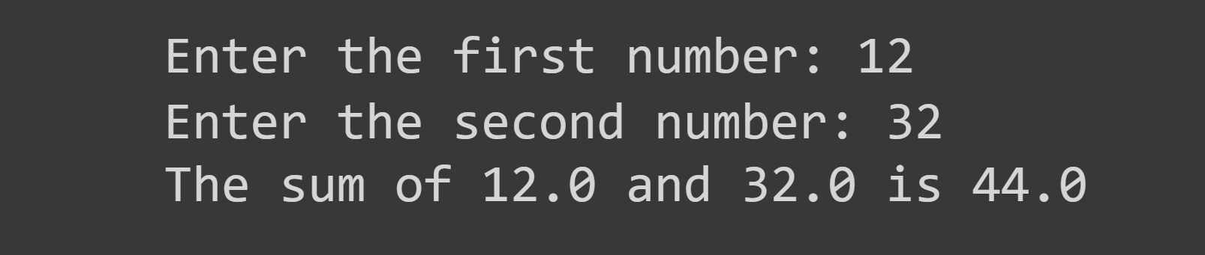

Program:

numbers = [1, 2, 3, 4, 5]

print("Original list:", numbers)

numbers.append(6)

print("List after adding 6:", numbers)

numbers.remove(3)

print("List after removing 3:", numbers)

print("Element at index 2:", numbers[2])

student_ages = {

    "A": 20,

    "B": 21,

    "C": 19,

    "D": 22

}

print("\nOriginal dictionary:", student_ages)

student_ages["E"] = 18

print("Dictionary after adding E:", student_ages)

del student_ages["B"]

print("Dictionary after removing B:", student_ages)

print("Age of A:", student_ages["A"])

colors = ("red", "green", "blue", "yellow")

print("\nOriginal tuple:", colors)

print("Element at index 2:", colors[2])

print("Iterating through the tuple:")

for color in colors:

    print(color)

Output:

